Bachelor MKI

Mobile Computing

SS 2020

Prof. Dr. Natividad Martínez Madrid

- Semester Project Documentation -

Neighbour in Need

Presented by:

Fanni Tamara Marosi, 764345

[Fanni\_Tamara.Marosi@Student.Reutlingen-University.De](mailto:Fanni_Tamara.Marosi@Student.Reutlingen-University.De)

Ebru Selin Özcelik, 764349

[Ebru\_Selin.Oezcelik@Student.Reutlingen-University.De](mailto:Ebru_Selin.Oezcelik@Student.Reutlingen-University.De)  
  
  
6. Semester

Submitted on: 15.07.2020

**Table of Contents**

[1 Introduction 3](#_Toc45636493)

[1.1 Motivation 3](#_Toc45636494)

[1.2 Goals of the project 3](#_Toc45636495)

[2 Personas and requirements analysis 3](#_Toc45636496)

[2.1 User groups and Personas 3](#_Toc45636497)

[2.2 Storyboards 7](#_Toc45636498)

[2.3 Requirement specification 8](#_Toc45636499)

[2.3.1 Functional requirements 8](#_Toc45636500)

[2.3.2 Non-functional requirements 13](#_Toc45636501)

[2.3.3 Nice-to-have requirements 14](#_Toc45636502)

[3 Conceptual model of the solution (using activity / sequence / ER - diagrams and mock-ups if applicable) 15](#_Toc45636503)

[4 Some design decisions about the implementation 16](#_Toc45636504)

[4.1 Firebase 16](#_Toc45636505)

[4.2 How to save the current user 17](#_Toc45636506)

[4.3 Main, Register and Login Activities 17](#_Toc45636507)

[4.4 Bottom Menu 17](#_Toc45636508)

[4.5 RecyclerView 17](#_Toc45636509)

[4.6 Create Advertisement Activities 18](#_Toc45636510)

[4.7 Sending an Email to another user 18](#_Toc45636511)

[5 Results (including how you did the testing and/or evaluation and the degree of completion of your requirements) 18](#_Toc45636512)

[5.1 Time schedule and project progress 18](#_Toc45636513)

[5.2 Testing and evaluation 18](#_Toc45636514)

[5.3 Degree of completion of our requirements 18](#_Toc45636515)

[6 Conclusion 18](#_Toc45636516)

# Introduction

This elaboration was written as part of the module “Mobile”. We implemented an Android application for the communality, which is called “Neighbour In Need”. Users can create and search for advertisements.

## Motivation

In times of the Coronavirus we thought about implementing an application, which helps people to find/offer help/things to others in their neighbourhood. The two of us wanted to help in the time of Corona lockdown, but we made the experience that there weren’t many platforms to connect to our neighbours and find someone who is looking for help. With this experience, we decided that there is need of such an application. It should be easily accessible for everyone and intuitive to understand and use.

## Goals of the project

The goal of this project was to implement an Android App, which has real benefits for the users. We wanted to create an App, which people would really use in their daily life. Users can register and create an account by specifying some information about themselves. This information contains a username, a password, an Email-address, the city, they live in and the post code. When logged in, users can create and search for advertisements, where others in their communality offer/search for things or their help. They can also create advertisements. Users could connect via the App and build their community.

# Personas and requirements analysis

This section includes our personas, storyboards, user stories and the requirement specification.

## User groups and personas

Our user group is very heterogeneous and for this reason we have three personas representing different user groups. Everybody except children could theoretically use and benefit from the App.

Amy Sue is a young student, Petra a middle-aged woman and Thomas is an older man. We introduce them and their use case scenarios on the following pages.

Ein Bild, das Screenshot enthält.

Ein Bild, das Text enthält.
Ein Bild, das Text enthält.

## Storyboards

We created two storyboards. Figure 1 shows Thomas, when he realises that he planted too many carrots. He lives by himself and fears to be forced throwing them away (picture 1). In the second picture the thinks about what he could do in order to solve this problem. With the help of our app he could easily take a picture of the food and create an advertisement (picture 3 and 4).

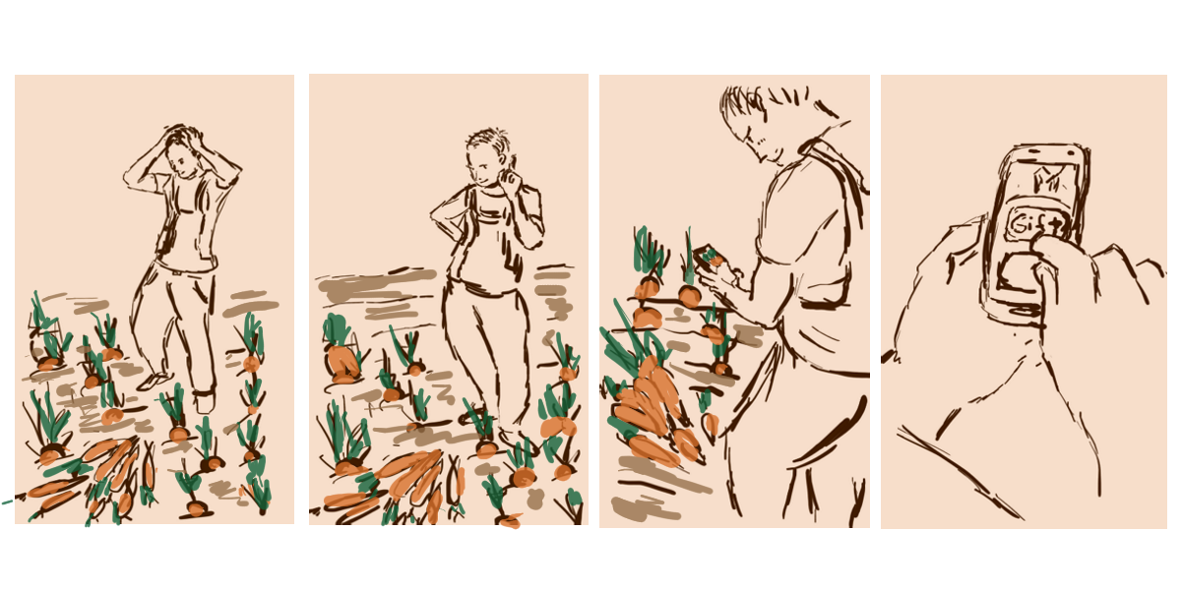

Figure 1: Thomas planted too many carrots

Below on Figure 2 Amy Sue is depicted. In the first picture she looks sad, because she has no more bottles of juice left. In the second picture she thinks about possible solutions. Then she creates an advertisement and asks for help. In the last picture we see her happy, because someone helped and took her to the supermarket.

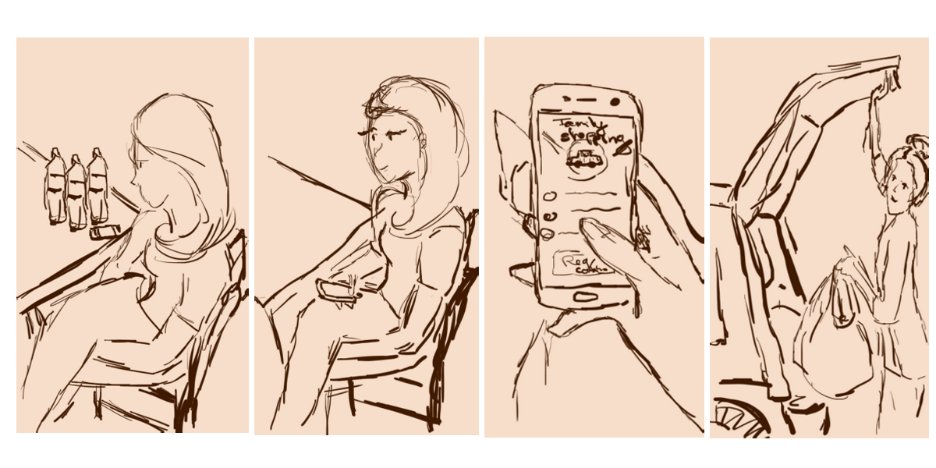

Figure 2: Amy Sue has no more bottles of juice left

## Requirement specification

This section contains the functional and non-functional requirements.

In order to reach an easier navigation and separation, we divided the advertisements into two main und three subcategories.

There are two main categories:

* "Search for help"
* "Offer help"

In both main categories the user can choose between three subcategories:

* "Give something for free"
* "Borrow/Lend something"
* "Offer help" (e.g. doing the shopping, work in the garden)

### Functional requirements

In the following we list and explain our functional requirements.  
The level of importance is stated via a scale from zero to five:

1 = not that important  
2 = nice to have  
3 = quite important  
4 = important  
5 = main or basic functionality.

|  |  |
| --- | --- |
| Requirement | Create an account |
| Number | 1 |
| Precondition | The user has already installed the application and has an email. |
| Description | The user should create an account with his/her personal information. Text box-> button (-> save in DB) |
| Rationale | - |
| Success criteria | The user must be able to enter all the necessary information; name, password, Email, phone number, post code |
| Level of importance | 5 |

|  |  |
| --- | --- |
| Requirement | Log in to own account |
| Number | 2 |
| Precondition | The user has already installed the application and created an account. |
| Description | The user can log in to the account by providing the username and the password. |
| Rationale | - |
| Success criteria | The system must verify the username and the password provided by the user by comparing with the data saved about him/her. If everything matches, the user will be logged in to own account by providing own username and password. |
| Level of importance | 5 |

|  |  |
| --- | --- |
| Requirement | Create an advertisement |
| Number | 3 |
| Precondition | The user has already chosen “Offer Help” as the main category. |
| Description | The user should be able to create an advertisement within both main categories (“Offer help” and “Search for help”). Here the advertiser must be able to specify one of the three subcategories ("Give something for free", “Borrow/Lend something", "Offer help"). The advertisement should contain additional information about the date, the way of shipping, a fitting category (e.g. gardening or household), post code and a short description. |
| Rationale | - |
| Success criteria | The user must be able to enter all the necessary information: category, post code, date, way of shipping, description. All the provided information will be saved and be able to access by other users, when searching for advertisements. |
| Level of importance | 5 |

|  |  |
| --- | --- |
| Requirement | Search for an advertisement |
| Number | 4 |
| Precondition | The user has already chosen between the three subcategories. |
| Description | The user should be able to search for an advertisement within both main categories (“Offer help” and “Search for help”). Here the advertiser must be able to search within the three subcategories ("Give something for free", “Borrow/Lend something", "Offer help"). |
| Rationale | - |
| Success criteria | The system will only show advertisements, which fit to the searching criteria. It will show the most important information of the advertisements: name of the item and name of the city. |
| Level of importance | 5 |

|  |  |
| --- | --- |
| Requirement | Pick one advertisement from the results |
| Number | 5 |
| Precondition | The user has searched for an advertisement and can see the result list. |
| Description | The user can pick one specific advertisement from the list of results in order to see all the other information. Therefore, the user needs to click on the container for the chosen advertisement. |
| Rationale | - |
| Success criteria | The system will show all the available information from the offering. |
| Level of importance | 4 |

|  |  |
| --- | --- |
| Requirement | Request personal information |
| Number | 6 |
| Precondition | The user has already selected one offering and is on the screen, where all information are shown about this item. |
| Description | When interested in interacting with one advertiser, the user should be able to request the contact information of the advertiser. In order to do so, the user can find a button at the bottom of the screen. |
| Rationale | - |
| Success criteria | The system will only show advertisements, which fit to the searching criteria. |
| Level of importance | 4 |

|  |  |
| --- | --- |
| Requirement | Account management/ Settings |
| Number | 7 |
| Precondition | The user is logged in. |
| Description | The user can choose to edit his/her personal information and photo by clicking on the “Profile” symbol. The symbol will be in a menu at the bottom of every screen. |
| Rationale | - |
| Success criteria | The user can now choose to edit his profile information, which includes; photo, personal information (and his/her ratings). |
| Level of importance | 3 |

|  |  |
| --- | --- |
| Requirement | Edit personal information |
| Number | 8 |
| Precondition | Setting Menu -> Personal Information |
| Description | The user can edit his/her personal information by clicking on the “Edit” symbol. |
| Rationale | - |
| Success criteria | The system will show all the saved information of the user and the user can now choose to edit his profile information, which includes; name, post code, address, email, phone number. |
| Level of importance | 3 |

|  |  |
| --- | --- |
| Requirement | Advertisement management “Offer” |
| Number | 9 |
| Precondition | The symbol in the menu bar at the bottom was clicked. |
| Description | The system will show all the advertisements the user has created. |
| Rationale | - |
| Success criteria | The user will get a list, which includes all the advertisements the user has created and can edit or delete the advertisements. |
| Level of importance | 3 |

|  |  |
| --- | --- |
| Requirement | Advertisement management “Borrow” |
| Number | 10 |
| Precondition | The symbol in the menu bar at the bottom was clicked. |
| Description | The system will show all the advertisements the user has recruited. |
| Rationale | - |
| Success criteria | The user will see a list with all the recruited advertisements. By clicking on a list item more information will be shown. |
| Level of importance | 3 |

|  |  |
| --- | --- |
| Requirement | Rate other users |
| Number | 11 |
| Precondition | The user must already have requested personal information from the other one. |
| Description | The user can rate the other by selected one to five stars and can create a comment. |
| Rationale | - |
| Success criteria | The rating will be saved and shown under the user’s profile. |
| Level of importance | 2 |

|  |  |
| --- | --- |
| Requirement | Sort the result list |
| Number | 12 |
| Precondition | The result list is open. |
| Description | When searching for advertisements, the user will be able to sort the list of results by clicking the sort button. Sorting criteria: distance and user rating. |
| Rationale | - |
| Success criteria | The system will sort the list according to the chosen criteria. |
| Level of importance | 1 |

### Non-functional requirements

In the table below we specify our non-functional requirements.

|  |  |
| --- | --- |
| **Non-functional Requirement** | **Description** |
| Performance | It shouldn´t take more than 3 seconds to load a screen. Furthermore, we want to reduce network usage and computing to save battery-life. |
| Portability | The application is supposed to run on different Android systems. |
| Screen Adaption | Device have different screen sizes, so the app should be able to scale according the target’s screen size. |
| Use-ability | The used symbols should be easy to understand, and the user should learn fast to interact with the system. The used colours are limited to an amount of four, in order to have not too many colours. |
| Security | We decided to save the data provided by the user encrypted and we only ask for information, which is necessarily needed. We constraint the input fields, e.g. to a certain amount of characters or for the post it is only possible to type in numbers. It means the user must pass the correct data type and the correct format within the correct range to pass the login/register screen. |
| Reliability | The system should reliable perform the function the user asked for. We want to send a short feedback to the user performing actions, e.g. if you request contact exchange from another user. |
| Accessibility | All the buttons should not be too small, so that everybody can easily use them. We decided not to use the colours red and green together, so this doesn’t confuse our users with red-green-weakness. |
| Availability | The application should be downloadable in the Google Play Store, where users can easily access and install it. |

### Nice-to-have requirements

We also detected requirements, which would be nice to have, but not necessarily needed for the main functionality of the application. We planned to implement them just in case we would time left at the end of the semester.

* *Rating system*, where users can rate and write comments about other users, after they interacted with each other
* *Chat function*
* *Geolocation*, in order to verify the address at the very beginning of the registration and for the search function, and *Maps integration* for the search function
* All the *legally* basics

# Conceptual model of the solution (using activity / sequence / ER - diagrams and mock-ups if applicable)

|  |  |
| --- | --- |
| *NeighbourInNeed_P1*  *Start Screen* | *NeighbourInNeed_P2*  *Choose between the two main categories* |
| *NeighbourInNeed_P3*  *Choose between three sub options*  *Offer* | *NeighbourInNeed_P4*  *Choose between three sub options*  *Search* |
| *NeighbourInNeed_P6*  *Show search results* | *NeighbourInNeed_P5*  *Show the details of the picked item* |
|  |  |
| *pfad*  *Layout Tree* | *color*  *Color Choice* |

# Some design decisions about the implementation

In this chapter we show some of our implementation designs and decisions.

## Firebase

Ein Bild, das Vogel enthält.
As we implemented a multi-user application, we needed a remote database to store the data and synchronize across all clients. For our database connection, we used Google Firebase Realtime Database, because our data structure is flat. Google offers Firebase Realtime Database, which is a cloud-hosted database. Data is stored as JSON representation.[[1]](#footnote-2) In Figure 3 below you can see the attributes of the user and the advertisements.

Ein Bild, das Vogel enthält.

Figure 4 Advertisement node in the database

Figure 3 User node in the database

## How to save the current user

After successful login an instance of the user will be saved in Prevalent.currentUser. This can be always be accessed from the other Activities of the Application. We build in a Remember me! Checkbox so that we can access the app again and again without the need to login every time. Whenever a user has entered username and password and the checkbox is clicked, then the app will remember that user and it will automatically login in the MainActivity. We used the Paper[[2]](#footnote-3) dependency to realize this feature. The dependency writes the user information to the Android memory so it will remember it the next time we use the app. First, we initialized the Paper library and then we could use the read and write methods to save and call the user date stored in the android memory.

## Main, Register and Login Activities

In the Main activity the if the user can login if he has already created an account or click on the register button and create a new one. If he clicked the Remember me Checkbox the user will be automatically enter the app. The Login Activity will acess the user data in the Firabase-database and if he user data is correct it will save the user keys in Paper than get the user to the next Activity. The Register activity will check the data in the text views and it will generate one new user instance in the Database if the data was correct.

## Bottom Menu

The BottomNavigationView is the main navigation what the user can use to switch between Activities. Android already has an xml template for menu with items. In the Item we can save the icon and a title. This manu will be used within our NavigationView. The Navigation view enables the switch between items by ItemID.

## RecyclerView

For displaying search results of our advertisements (search function), we used a RecyclerView in combination with an Adapter class. We also used it in order to display the user’s own advertisements. It is recommended to use RecyclerView when the data, which should be displayed, could change at runtime. The Adapter manages the collection of data and binds it to the view.

We also implemented a ClickListener for all Views in the RecyclerView. Another activity, showing all information about the advertisement will be displayed, when an advertisement is clicked.[[3]](#footnote-4)

Ein Bild, das Screenshot enthält.
Ein Bild, das Screenshot enthält.
Ein Bild, das Screenshot enthält.

Figure 7 Filter search results by subcategory

Figure 6 Filter search results by main category

Figure 5 Search function

## Create Advertisement Activities

All Activities that starts with CreateAd are somehow related to process of creating an Advertisement. In the CreateAdSubcategory the suer can choose between Search and Offer. After clicking one of the buttons the user can choose between the three subcategories. If the user successfully chosen a subcategory, he can now create his advertisement. The user nee d to fill all the field sand add an image to the ad.

## Sending an Email to another user

At first, we didn’t know, how to implement this requirement.

# Results (including how you did the testing and/or evaluation and the degree of completion of your requirements)

## Time schedule and project progress

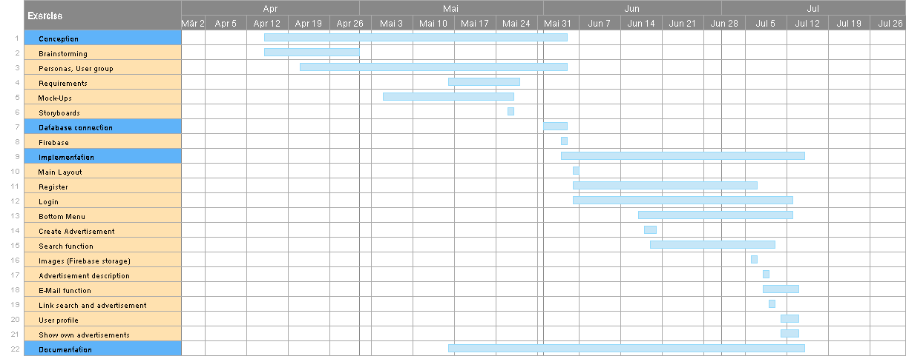

## Testing and evaluation

We decided not to write any explicit tests but tested every feature via the application UI, by checking the values in the database and viw logs in the code.

We also asked our friends to test the application by clicking through and giving us feedback.

## Degree of completion of our requirements

# Conclusion

The focus in this project was on working with Android Studio. The work consisted of two parts. In one part we designed the layouts using the editor or the xml-file. The other part contained implementing the logic of the app, which we did in Java.

We liked Android Studio, because it has a quite fast learning curve and we found some helpful tutorials on YouTube. Overall you can find a lot of tutorials and solutions on the Internet. In summary we managed implementing our main functions. Due to lack of time, we couldn’t implement all the requirements, we specified.

1. https://firebase.google.com/docs/database [↑](#footnote-ref-2)
2. https://github.com/pilgr/Paper [↑](#footnote-ref-3)
3. https://guides.codepath.com/android/using-the-recyclerview [↑](#footnote-ref-4)